Exercise 5: MQTT Reliability, QoS Handshakes, and Retained Messages
Week: 5 (Hands-On Laboratory Exercise)
Objective: To reverse the publisher/subscriber roles between Postman and Node-RED, explicitly define Quality of Service (QoS) levels, utilize the Retain flag for asynchronous state management, and capture the resulting TCP/IP handshakes using Wireshark.
Step 1: Role Reversal - Configuring Node-RED as the Subscriber
Previously, Node-RED published data. Now, we will configure it to listen passively as the Subscriber, allowing us to inspect incoming messages in the debug console.
1. Add an MQTT In Node: In your Node-RED workspace, drag an mqtt in node onto the canvas. Double-click it to configure:

○ Server: Ensure it is pointing to your local EMQX broker (localhost:1883).
○ Topic: campus/qos/test
○ QoS: Set this to 2 (This ensures Node-RED is capable of receiving messages at all QoS levels up to 2).

2. Wire to Debug: Drag a green debug node, wire the mqtt in node to it, and ensure the debug node is set to output the complete msg object.
3. Deploy: Click Deploy. Node-RED is now actively listening to the broker.

Step 2: Wireshark Initialization & QoS 0 (Fire and Forget)
We will use Postman to publish messages and Wireshark to observe the exact network overhead required for each level of reliability.
1. Start Packet Sniffing: Open Wireshark, select your loopback adapter, and apply the display filter: tcp.port == 1883 (or simply mqtt).
2. Configure Postman Publisher: Open Postman and establish an MQTT connection to mqtt://localhost:1883.

○ Go to the Message tab (where you publish).
○ Set the Topic to campus/qos/test.

○ Type a JSON payload: {"test": "QoS 0 execution"}.
○ Ensure the QoS dropdown is set to 0 and Retain is unchecked.

3. Execute & Analyze: Click Publish.

○ Check Node-RED: The message should appear in the debug window.
○ Check Wireshark: You will see exactly one packet labeled MQTT Publish Message. There is no response from the broker. This is a blind "fire and forget" transmission.

Step 3: Verifying QoS 1 (At Least Once) and QoS 2 (Exactly Once)
As we increase reliability, we exponentially increase network overhead. Let's capture the cryptographic handshakes.
1. Test QoS 1: * In Postman, change the payload to {"test": "QoS 1 execution"} and change the QoS dropdown to 1. Click Publish.

○ Look at Wireshark. You should now see two packets. First, the Publish Message from Postman. Second, a return packet from the broker labeled Publish Ack (PUBACK).

2. Test QoS 2:

○ In Postman, change the payload to {"test": "QoS 2 execution"} and change the QoS dropdown to 2. Click Publish.
○ Look at Wireshark. You will now see a rigorous four-way handshake.
○ You will capture: Publish Message, followed by Publish Received (PUBREC), followed by Publish Release (PUBREL), and finally Publish Complete (PUBCOMP).

Step 4: The Retain Flag Mechanism
What happens if a dashboard wants to know the current temperature, but the sensor only publishes once an hour? We use the Retain flag to force the broker to cache the last known state.
1. Disconnect the Subscriber: In Node-RED, double-click the wire connecting your mqtt in node to the debug node to delete it. Click Deploy. Node-RED is no longer processing messages.
2. Publish a Retained Message: In Postman, set the Topic to campus/state/door.

○ Set the payload to {"status": "OPEN"}.
○ Crucial Step: Toggle the Retain setting to True (or check the Retain box).
○ Click Publish. (Because Node-RED is disconnected, the message seems to go

nowhere).

3. Reconnect the Subscriber: In Node-RED, re-wire the mqtt in node to the debug node. Change the topic in the mqtt in node to campus/state/door. Click Deploy.
4. Observe the Magic: Instantly upon deployment, the {"status": "OPEN"} message will appear in your Node-RED debug window! The EMQX broker held the message in memory and immediately handed it to the new subscriber.
5. Wireshark Analysis: Look at the Publish Message packet in Wireshark for that retained transmission. Expand the Fixed Header. You will clearly see the Retain: Set bit toggled to 1.

Part 5: Discussion & Architectural Analysis
Based on your network packet captures, answer the following questions:
- You observed that QoS 0 requires 1 packet, QoS 1 requires 2 packets, and QoS 2 requires 4 packets. If you are designing a battery-powered ESP32 temperature sensor that updates every 10 seconds, which QoS level would you choose and why? What are the mathematical consequences on battery life and bandwidth if you incorrectly select QoS 2 for this scenario?

- Explain the fundamental difference between standard MQTT message delivery and a Retained message. Give a real-world Industrial IoT (IIoT) scenario where a Retained message is absolutely mandatory for system safety when a new client connects to the broker.

Result:
When QoS 0: 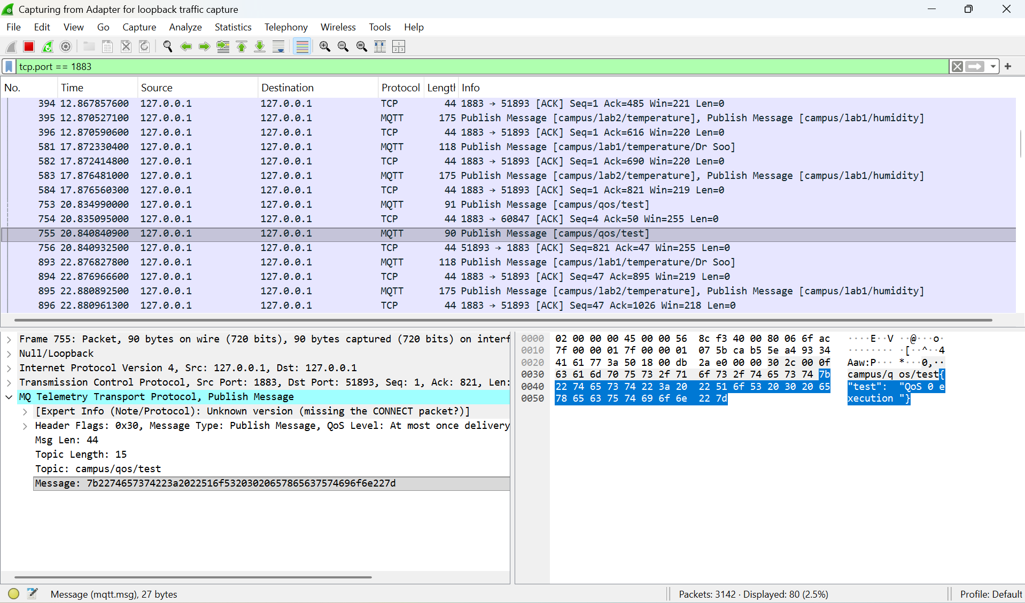
When the message was published using QoS 0, only a single MQTT PUBLISH packet was observed in Wireshark. There was no acknowledgment packet returned by the broker. This confirms that QoS 0 does not guarantee delivery confirmation or retransmission.
In Node-RED, the message was still successfully received and displayed in the debug window. However, Wireshark showed no additional handshake or response packets from the broker, indicating minimal network overhead.

When QoS 1:
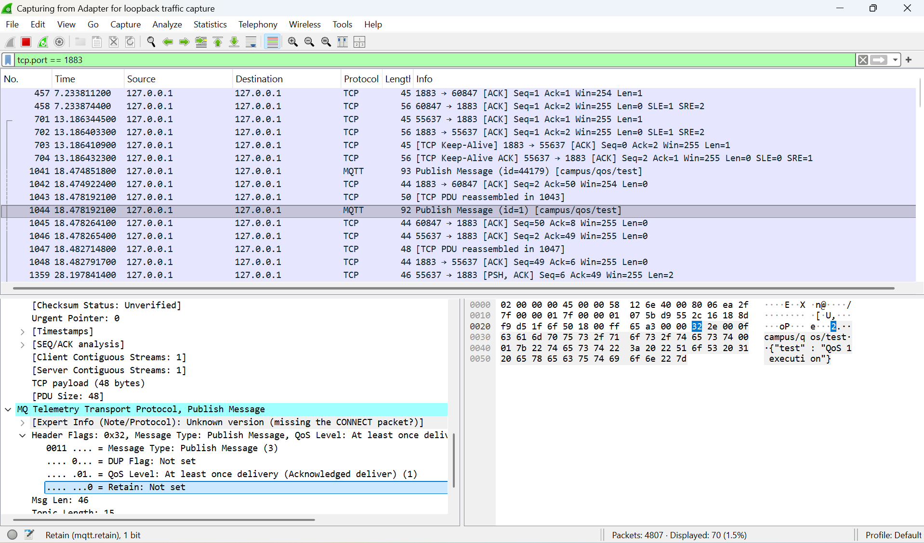
When QoS 1 was selected, Wireshark captured two packets at lines 1041 and 1044 during communication. The first packet was the MQTT PUBLISH message at line 1041 sent from the client (Postman), and the second packet was a PUBACK acknowledgment at line 1044 returned by the broker.
This confirms that the broker acknowledges receipt of the message, ensuring that the message is delivered at least once. If acknowledgment is not received, the message may be retransmitted.

When QoS 2:
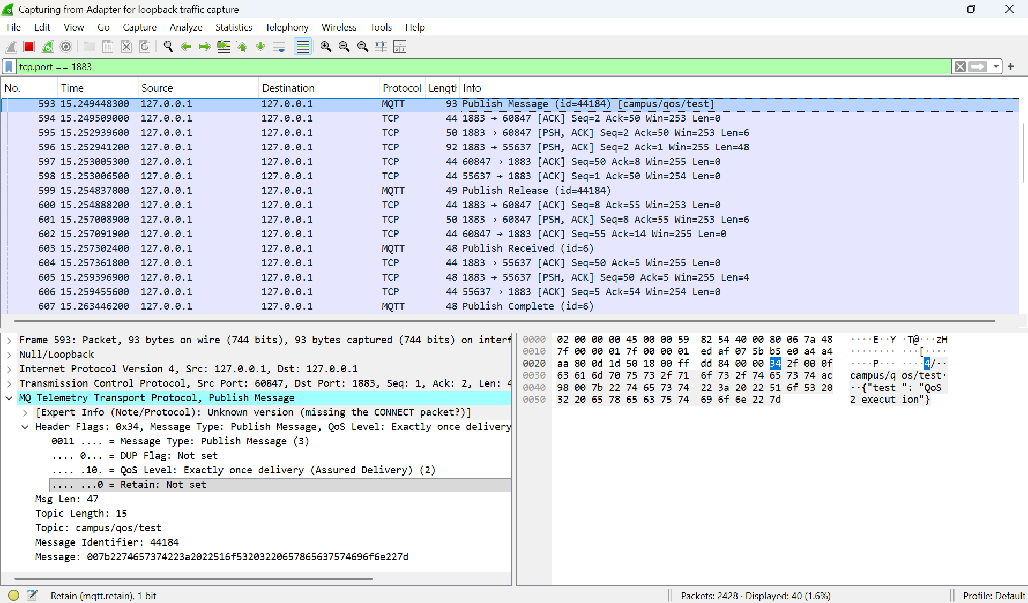
When QoS 2 was used, Wireshark captured a four-step handshake process between the client and broker. The sequence observed was:
- PUBLISH (Client → Broker) at line 593
- PUBREC (Broker → Client) at line 599
- PUBREL (Client → Broker) at line 603
- PUBCOMP (Broker → Client) at line 607
This confirms that QoS 2 ensures exactly-once delivery by using a complete acknowledgment handshake to prevent duplication.
Node-RED successfully received the message only once, confirming correct delivery semantics despite multiple packet exchanges.

When retained but without connection:
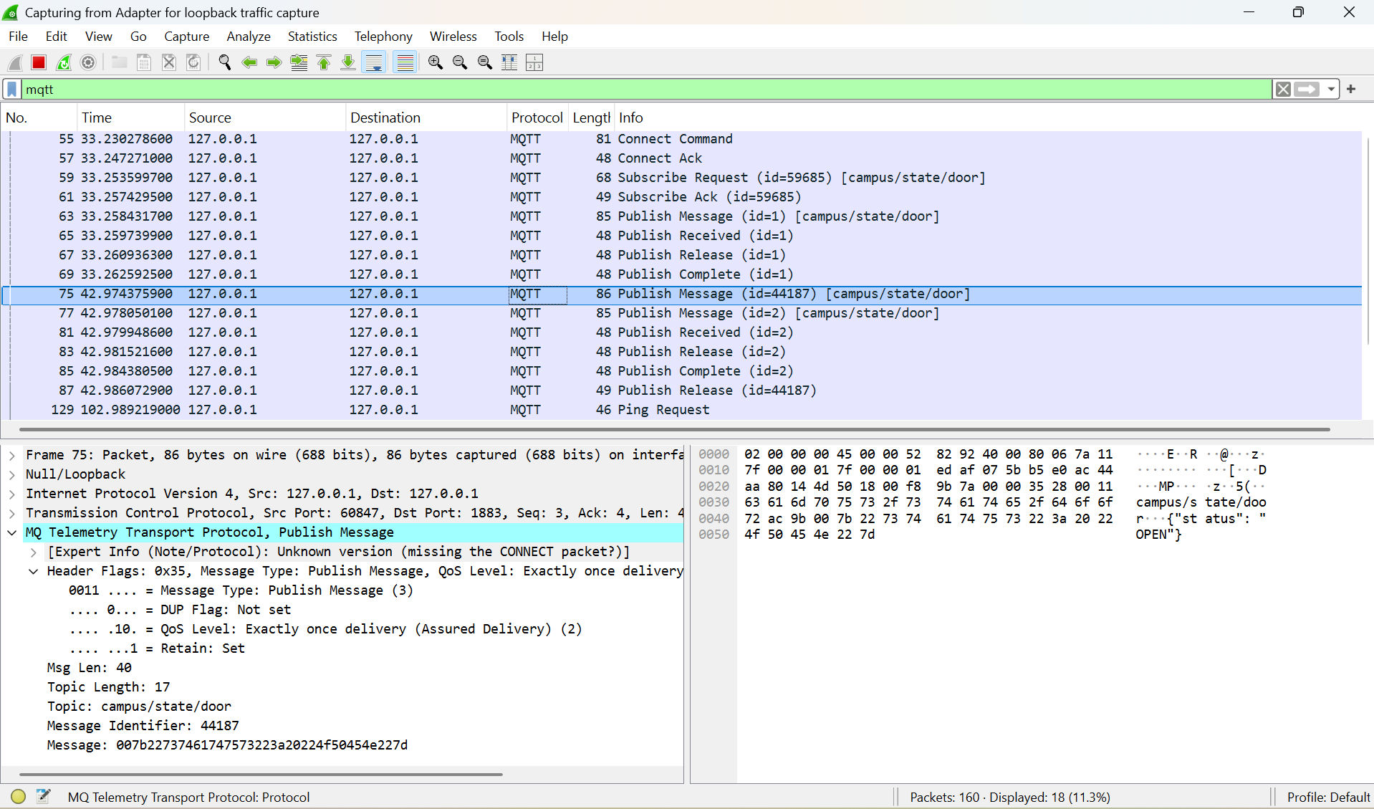
When a message was published with the Retain flag enabled, but the Node-RED subscriber was disconnected, Wireshark still showed a normal MQTT PUBLISH packet with an additional Retain flag set to 1 in the header.
At that time, Node-RED did not display any message because it was not connected or subscribed to the topic.
This indicates that the broker stored the last published message for that topic even though no active subscriber was present.

When retained and with connection:
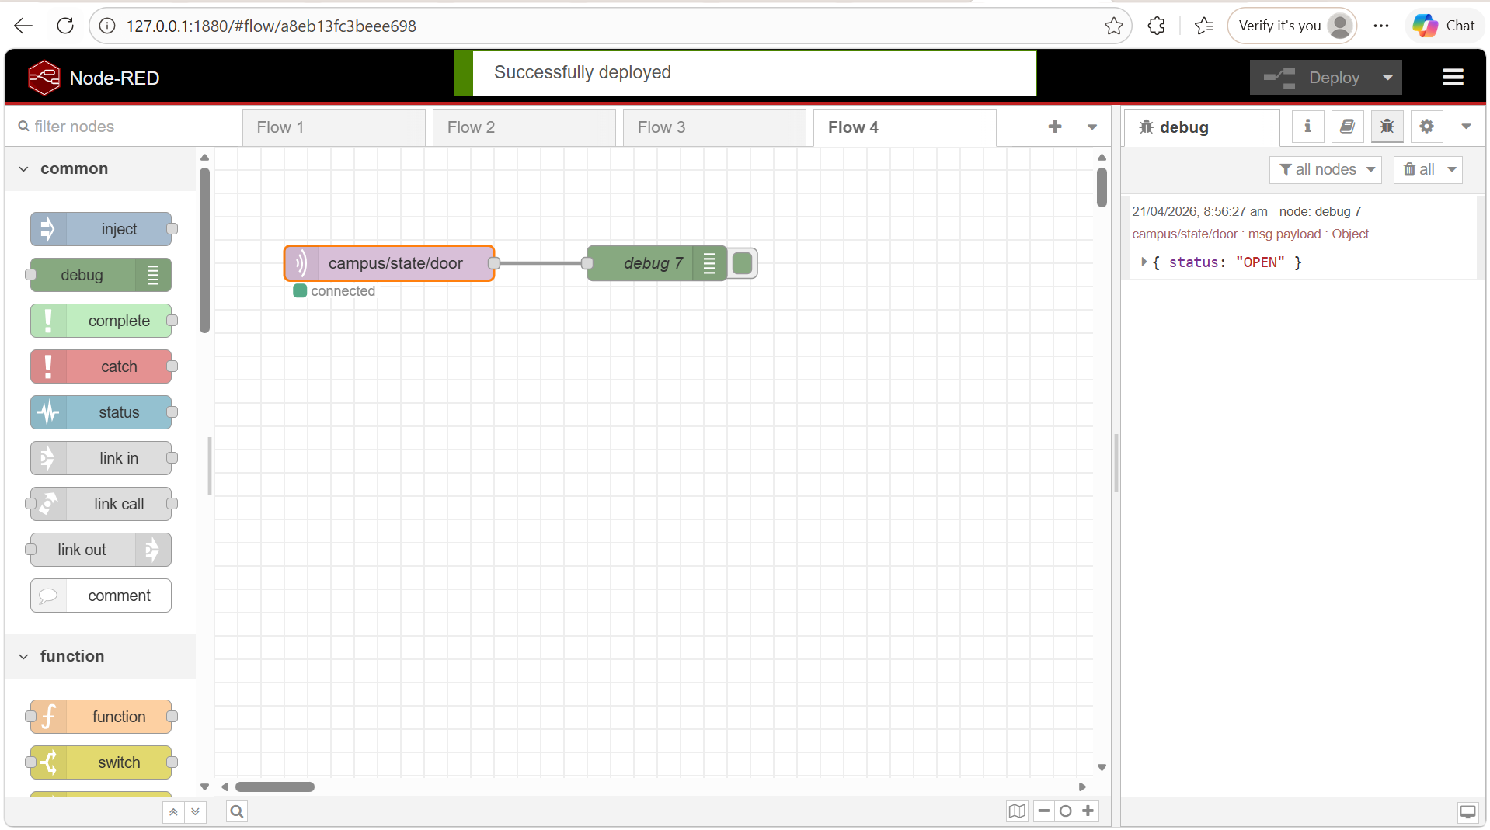
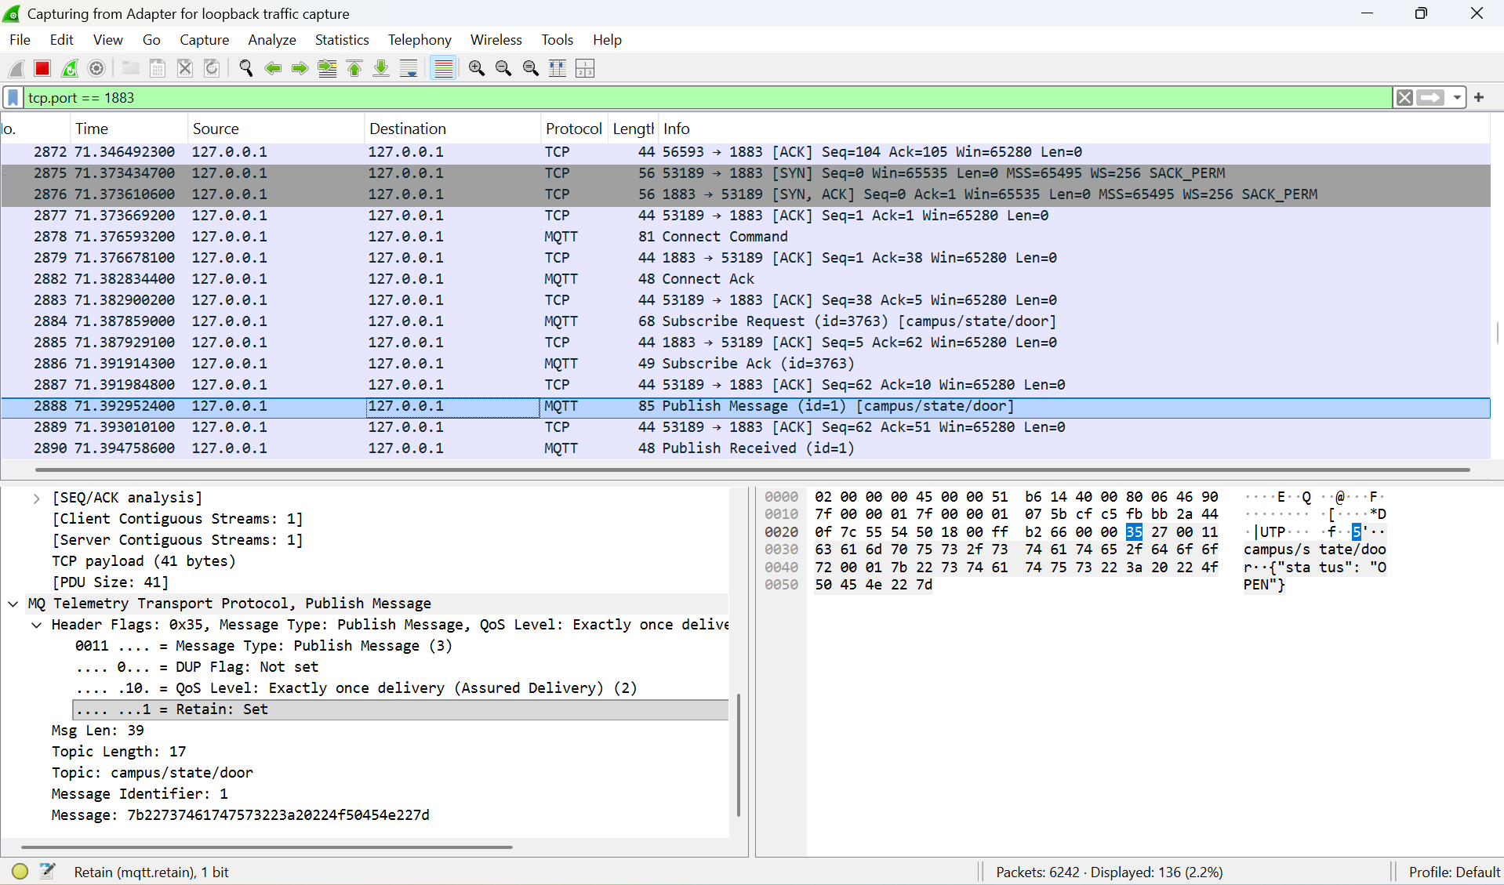
After reconnecting Node-RED and subscribing to the same topic, the retained message was immediately delivered without requiring a new publish action.
Wireshark showed that the message was sent instantly upon subscription, confirming that the broker automatically forwards the stored retained message to new subscribers.
This demonstrates that retained messages act as a “last known state” mechanism in MQTT.

Discussion and question:
1. For a battery-powered ESP32 temperature sensor that transmits data every 10 seconds, the most suitable QoS level is QoS 0 because it uses only one packet per transmission, making it the most energy-efficient option. Since temperature data is periodic and non-critical, losing a single message is acceptable because a new reading will be sent shortly after. In contrast, using QoS 2 would require four packets per transmission, resulting in approximately four times more energy consumption and bandwidth usage, which would significantly reduce battery life and increase network overhead unnecessarily.
2. The fundamental difference between a standard MQTT message and a retained message is that a standard message is only delivered to subscribers that are currently connected at the time of publishing, whereas a retained message is stored by the broker and immediately delivered to any new subscriber when it connects. A retained message ensures that the latest system state is always available, even if the subscriber was offline when the message was originally published.
A critical Industrial IoT scenario where retained messages are mandatory is in a gas leak detection system. If a gas sensor publishes a “leak detected” status without using the retain flag and a monitoring system connects afterward, it would not receive any information and might incorrectly assume that the environment is safe. However, if the message is retained, the broker will immediately deliver the latest “leak detected” status to the new client upon connection, ensuring that safety systems can respond instantly and prevent dangerous situations.

Conclusion
This laboratory exercise successfully demonstrated the differences in MQTT Quality of Service (QoS) levels and the behavior of retained messages through practical implementation using Node-RED, Postman, EMQX broker, and Wireshark packet analysis.
From the observations, it was clearly shown that QoS 0 provides the lowest network overhead, requiring only a single PUBLISH packet with no acknowledgment, making it suitable for non-critical, frequently transmitted sensor data such as temperature readings. QoS 1 introduced a PUBACK acknowledgment, ensuring at least once delivery but increasing network traffic. QoS 2 required a full four-step handshake (PUBLISH, PUBREC, PUBREL, PUBCOMP), providing exactly-once delivery at the cost of significantly higher communication overhead.
The experiment also demonstrated the functionality of the MQTT Retain flag, where the broker stores the last known message for a topic. It was observed that retained messages are not delivered immediately when no subscriber is present; however, once a new subscriber connects, the broker instantly delivers the stored message. This confirms that retained messages are essential for maintaining the latest system state in IoT applications.
Overall, the experiment highlights the trade-off between reliability and efficiency in MQTT communication. Higher QoS levels improve delivery guarantees but increase bandwidth usage and processing overhead, while retained messages enhance system reliability by ensuring state availability for newly connected clients. These concepts are critical in designing efficient and reliable Industrial IoT systems.

